Economics Project: Global Financial Crisis and its Impact on Saudi
Name
Professor
Course
Date

Economics Project: Global Financial Crisis and its Impact on Saudi
Introduction
The international financial crisis began due to the subprime crisis in USA in 2007. USA had introduced some not well planned incentives throughout the years to encourage development which led to a false bubble. This bubble burst in 2007 and it brought about foreclosures, failed financial systems and spread of financial crisis. The crisis could spread all the more impactively to the advanced economies because of their exposure to toxic assets of US and having comparative policies.
The expression "financial crisis" focuses to the unexpected lessening in the prices of an asset which may be a material, for example, hardware and gear, or financial, for example, offers and securities. The abrupt diminishing may occur because of the cost bubble, which may mean a major and unexpected increase in prices finishing off with their unexpected breakdown. Specialists, legislators and chiefs all over the world affirm that the current financial crisis is hazardous and profound and that it will proceed for a time of a few years (Abdelbaki, 2010).
Statistical reports point to the way that the number of unemployment all over the world will increase by 51 million amid the coming two years. The international monetary development will diminish from 3 to 4% (to about half percent). It likewise means that the profundity of the crisis is the abatement of monetary pointers in international and state currency markets and the volume of resulting misfortunes in that. Likewise, the chapter 11 of mammoth global organizations, for example, Lehman Brothers, which is viewed as a standout amongst the most prominent banks in the world in various financial services, and American Insurance Group (AIG), the guarantor of revenues for a few American land reserves and eighteenth spot in the rundown of the greatest business entities, is viewed as another impact of the crisis and its profound impact (Abdelbaki, 2010).
There have been a few research papers that have endeavoured to give theories on globalization of financial crisis. Achalapathi et. al. (2011) provided an outline of four theories that clarify explanations behind international financial crisis. Jones and Ocampo (2009) – Transmission Mechanisms of Crisis: Jones and Ocampo (2009) proposed three systems that encouraged transmission of financial crisis from the created to creating nations: remittances, capital streams and trade. Firstly, remittances that originate from workers or trade would demonstrate a quick impact because of the standard of money dollar. The majority of the Gulf Cooperation Countries (GCC) are intensely subject to foreign workers particularly for the development employments in the locale. A change in the money would instantly affect the workers remittances. Furthermore, private capital is another key channel of transmission of crisis from created to creating economies. This impact is observed to be more extreme for developing economies instead of low salary nations that are not very much integrated into international private markets. The stream of monetary guide likewise gets upset amid retreat that is bound to influence the poor nations. Lastly, trade is an essential and almost certain system to transmit the impacts of crisis to exporters of manufactures and services. The trade volumes and prices demonstrate a noteworthy decay that influences the general interest and supply circumstance of a nation. This theory recommends to combat the negative impacts of trade transmission through international and national policy measures.
Rao (2009) – Decoupling Theory failed: According to decoupling theory, the advanced economies would go into a downturn amid crisis yet the rising economies would stay solid because of their sound foreign reserves, improved arrangement structure, solid corporate monetary records and a well-working financial division. The proof from the international financial crisis of 2007, for example, capital inversions, unexpected cash deteriorations, sharp broadening of spreads on sovereign and corporate obligation recommends the disappointment of decoupling theory. Rao (2009) recommends that decoupling theory was negated amid the international financial crisis as the rising economies also have been influenced by the crisis.
Crisis in Perspective: Global Impact
The world trade volume was reported to have fallen an expected 15 percent curing the main quarter of 2009 (Freund, 2009). There was a huge drop in international interest, which thus influenced the decrease in trade and items crosswise over nations. European Union (EU) was at the focal point of international financial crisis that majorly affected the patterns in trade. In the primary portion of 2009, there was a decay of trade by 21.5 percent in contrast with a similar time of 2008 (Curran, 2009). Berkmenet al., (2009) explored the impact of international financial crisis on an economy's yield through the trade linkages. Inside trade linkages, the investigation included factors of trade receptiveness, trade creation, and heading of trade. With connection to the example explored, it was discovered that trade transparency was not factually huge, however the arrangement of trade was significantly influenced. The ratio of assembling items to add up to fares was corresponded to more awful development performance for both progressed and creating nations. Nations that were trading fabricating products to cutting edge economies were hit hard because of the decrease in their interest.
The Asian economies confronted a more prominent impact because of the international financial crisis in 2007 in contrast with the past downturns as they have picked up conspicuousness throughout the years through broad trade and financial incorporation, particularly with the USA (International Monetary Fund, 2008).
On expansion, International Monetary Fund, (2010) saw that debilitating import prices and emptying house prices in the wake of the financial lull helped turn around inflationary patterns beginning in the principal half of 2009. Inlet Cooperation Council (GCC) nations swelling declined to 2 percent by the second from last quarter of 2009 from 10½ percent at end-2008 (Figure 1).
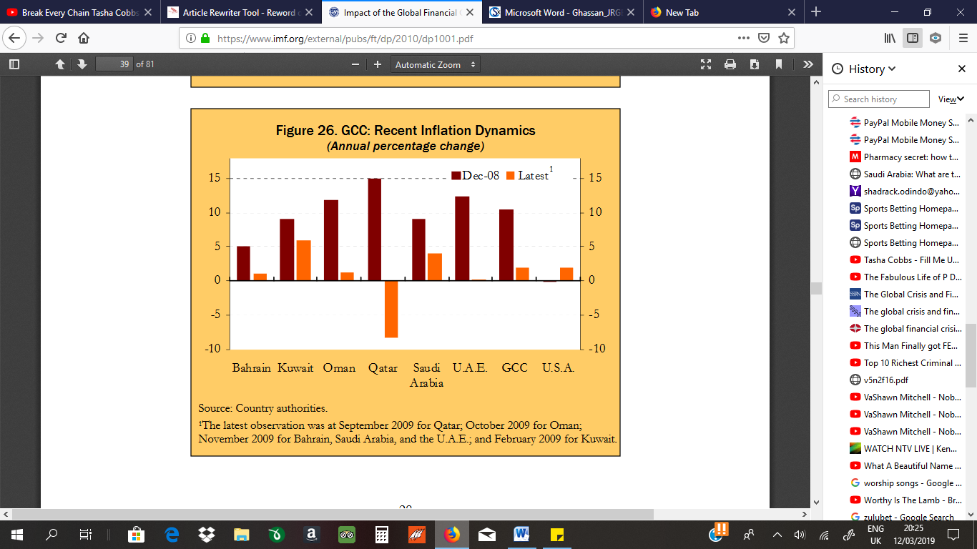
Figure 1: GCC Recent Inflation Dynamics
Impact on Saudi
The impact of international financial crisis could be seen even in Saudi Arabia, straightforwardly through more tightly international financing conditions and flimsier speculator certainty that prompted an immediate association with local equity markets going down. In 2009, the nation needed to cut oil generation by 8.7 percent because of the circuitous impact of the sharp decrease of oil prices by 36 percent (International Monetary Fund, 2012). Saudi banks presentation to mortgage upheld securities and other securitized resources were just 3 percent of the net resources toward the start of the crisis. In any case, the spread between the Saudi interbank offered rate and the switch repo rate had expanded more than 200 premise indicates in October 2008 due international liquidity deficiencies that transmitted to the interbank market. However, Saudi Arabian Monetary Agency (SAMA) quickly swung enthusiastically and reestablished trust in the market.
The negative impacts on international liquidity of Saudi Arabia were caused firstly by the disintegration of the monetary and genuine resources esteems for the most part in United States, furthermore by the decrease in oil revenues because of lower request of the industrialized economies. These impacts prompted a colossal decrease in the international oil prices from 145 dollars for every barrel to 40 dollars amid the final quarter of 2008 and the first quarter of 2009 (Ghassan et al, 2013).
In any case, since start of the third thousand years and before the crisis, the aggregation of the international liquidity, because of the excellent increase in oil prices amid the second from last quarter of 2008, added to retain the negative impacts of the international financial crisis on Saudi economy (Ghassan et al, 2013).
The financial report of SAMA shows the expansion of outside Saudi banks ventures amid 2009 which achieved a high record. This raise results somewhat from the decrease in the reserves returns because of the nonattendance of government securities discharge amid 2009 and the lessening in local switch repo rate chosen by SAMA, on the grounds that the national bank thinks about that there is no household liquidity overabundance in the economy (Ghassan et al, 2013).
However, this prompts increase the dimension of liquidity in banks, and after that the banks contribute their overabundance liquidity abroad, so the net outside resources of banks recorded a critical increase between the final quarter of 2008 and 2009. The developing of cash supply at quicker rate, contrasted with the GDP development, mean that the Saudi Arabia economy experience the ill impacts of the fiscal hazard expansion (Figure 2).
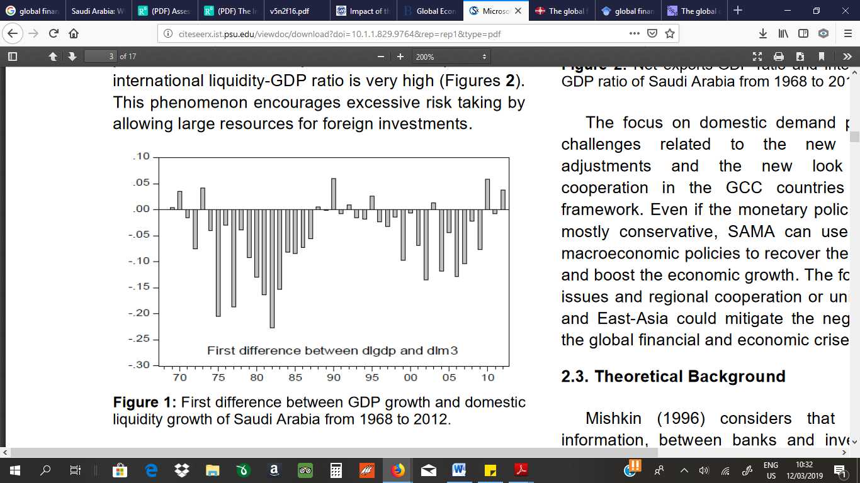
Figure 2: First difference between GDP growth and domestic liquidity growth of Saudi Arabia from 1968 to 2012.
What's more there is a “glut saving" phenomenon since fares surpass imports and global liquidity-GDP ratio is exceptionally high (Figures 3).
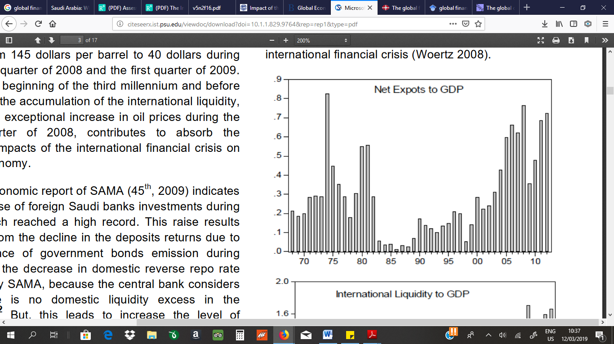
Figure 3: Net exports-GDP ratio of Saudi Arabia from 1968 to 2012.
This phenomenon empowers unnecessary hazard taking by permitting substantial assets for foreign theories.
Saudi Response
In 2013, Saudi Arabia remained at a positioning of 86th position for the Trade Freedom Scores out of 181 positions (Riley and Miller, 2012). This positioning demonstrates a relationship between trade freedom and improved existences of individuals around the globe. It is discovered that nations that have the most trade freedom will have attributes of higher per capita pay, lower rates of craving in their populaces, and cleaner conditions. Saudi Arabia's positioning mirrors its halfway methodology in taking care of the measure of trade freedom permitted by the government.
Saudi Arabia had the capacity to battle the impact of international financial crisis in 2007 by reinforcing its situation throughout the years. The specialists had found a way to pay off the open obligation that contained 104 percent of GDP in 1999 to around 13 percent in 2008 (International Monetary Fund, 2012). This prompted a more grounded asset report of the government and more noteworthy monetary flexibility. Moreover, the net foreign resources additionally improved from 23 percent of GDP to 92 percent in a similar period that gave the nation a financial space to go up against the crisis mightily.
The government had presented a solid monetary policy reaction to direct the macroeconomic impact of the crisis. The specialists reported a huge financial upgrade bundle in 2009 which prompted the non-oil part developing by 3.5 percent around the same time. The nation's expansion reacted to the bundle by moving from 11 percent in 2008 to 4.2 percent before the end of 2009.
A major factor influencing the experience of international and Saudi banks amid the turbulent time of 2008 and 2009 was the sound performance of the Saudi financial segment, which kept on demonstrating solid gainfulness and development amid that period. The rate of profit for normal value for 2008 was 20%, and for the nine months to September 2009 it remained at 16%.
These strong returns in a time of turbulence and unpredictability are extremely positive and agreeable. Saudi banks are all around promoted by international gauges, and demonstrated a normal Basel capital ampleness ratio of 16% in 2008 (15.9% in September 2009). It is important that practically all the capital of Saudi banks is Tier 1 capital. What's more, the nature of Saudi banks' resources stayed solid, with non-performing advances (NPLs) adding up to 1.4% of all out credits what's more, propels at end-2008, while arrangements inclusion was at 153%. NPLs stayed below 3% at September 2009. Banks kept on being exceptionally fluid, with fluid resources speaking to a normal of 34% of all out client reserves in 2008. The solid circumstance winning at end-September 2009 has proceeded with unabated, with a liquidity ratio at over 30% (Al-Hamidy, 2010).
Saudi Arabia is viewed as an open economy with a reasonably changed monetary record. The nation places confinements on the foreign support in the equity markets. Regarding global linkages, there is noteworthy trade and payments identified with oil division and expanded remittances of foreign specialists. Cross – outskirt linkages isn't in all respects obviously noticeable in the nation to inaccessibility of precise information. It is discernible to see that local business banks have as of late worked in different nations by setting up branches and there is an improved nearness outside banks in Saudi Arabia. Outside resources of focal government, which represent 90 percent of all out monetary resources, are generally overseen by SAMA.
Role of foreign Exchange reserves and interventions
In the wake of the financial crisis, the essential objective of regulatory agencies international has been to fortify international regulatory guidelines, improve straightforwardness in international monetary markets and guarantee that every one of those business sectors, their items and members are properly directed or subject to oversight, contingent upon their conditions. Notwithstanding stable market honesty guideline, a macroprudential policy is prompted in which national and global coordination between financial foundations is basic to guarantee a system wide way to deal with monetary guideline so as to manage fundamental hazard. The exact opposite thing that controllers need is another circumstance where they have to depend on non-customary monetary (and monetary) policies, which are expensive and, in this manner, not supportable. Thusly, future changes to the regulatory structure should concentrate on limiting those dangers, which were not joined in past guidelines (Al-Hamidy, 2010).
Saudi Arabia did not need to take any measures to help the foreign cash renegotiating of banks/partnerships; this is on the grounds that Saudi Arabia is a net capital exporter and Saudi banks' benefit/risk the board is moderately traditionalist. The SAMA just led FX swaps with household banks to give dollar liquidity so as to fulfil the financial system's need for FX (Al-Hamidy, 2010).
Recommendation and Conclusion
Saudi Arabian imports and fares have appeared in general increase in the course of the most recent 10 years. The macro - monetary strategies after the international monetary crisis have had the capacity to secure the nation from any unfavorable impacts. However the nation's GDP has been appearing of declining development rates. The nation still vigorously depends on dominatingly oil trades and the change of prices in the international market would decide the revenues earned by the economy.
As recommended by Jones and Ocampo (2009), trade was one of the vital transmission components of the crisis for Saudi Arabia as the actual data indicate. Decoupling theory can't be approved on account of Saudi Arabia. The country saw a decrease in its general trade exercises in 2008-2009 because of the transmission of stuns from the international financial crisis. Saudi Arabia endured less serious stuns as real piece of its fares is in crude materials instead of cutting edge producing merchandise. This is in accordance with the clarification of cross country contrasts on impact of crisis clarified by Berkmen et al. (2009).
The wide ends with particular to the destinations of this paper demonstrates that an investigation of real insights in the past segment proposes, Saudi Arabia has constantly kept up a positive parity of trade payment from 1988 to 2013 notwithstanding amid the crisis time of 2007-2009.
Saudi Arabia has kept up a general development rate in its GDP over 5 percent from 2003 to 2008. The crisis time frame saw a rate development rate of just 1.83 percent in the GDP. The later monetary strategies of the nation have pushed down the development rates to around 3 percent. Saudi Arabia is a noteworthy exporter of crude materials while its imports are a higher level of completed items. Its significant clients for the fares are Asian nations that are not Arabic and not Islamic. Their real rates of imports are from European nations.
Given its global dimension, the crisis presented enormous difficulties for policymakers on numerous fronts. Financial and value steadiness are basic to macroeconomic soundness. In the previous two decades, financial arrangement went for low and stable expansion and, shockingly, the accomplishment of fiscal strategy ended up being a piece of the issue. This is on the grounds that unreasonable motivating forces (made by the continuation of low loan prices and low expansion) prompted a higher craving for hazard taking, in this way destabilizing the economy in the more extended term. In ordinary occasions, intemperate or quick money devaluation would warrant the upkeep of high loan prices. The fundamental policymaking objective amid the present crisis was to turn away flattening/sorrow. The money factor did not oblige national banks' energy to bring down loan fees as a component of their reflationary objective.
Despite the fact that there was no subprime mortgage crisis in Saudi Arabia, the monetary crisis in international markets raised apprehensions and made some vulnerability in the Saudi interbank market.
Thusly, the Saudi interbank offer rate (Sibor) rose pointedly in the consequence of the breakdown of Lehman Brothers, achieving a dimension of more than 200 bp over the reverse repo rate. Moreover, there were fears that the evaporation of liquidity in the international interbank markets would be passed on to the entire of the financial system.
The nation needs to help development in different parts. The development of an economy is reliant on the general advancement and commitments from different areas. Trade is a component that needs positive measures to help the certainty of the general nation's activities. Saudi Arabia's trade and its large scale monetary arrangements were extremely advantageous to improve its reaction to the crisis and the period from that point. Saudi Arabia should help trades in different segments to decrease its dependence on the oil segment. They likewise need to find more up to date markets or encourage expanded association with existing nations to reinforce its situation in the world.

References
Abdelbaki, H. (2010). Assessing the Impact of the Global Financial Crisis On GCC Countries. Journal of Business & Economics Research (JBER). 8. 10.19030/jber.v8i2.682.
Al-Hamidy, A. (2010). The global financial crisis: impact on Saudi Arabia. Bank of Israel Rony Hizkiyahu, 347. Retrieved from: https://www.bis.org/publ/bppdf/bispap54u.pdf
Berkmen, P., Gelos, G., Rennhack, R., And Walsh, J., P. 2009. The Global Financial Crisis: Explaining Cross-Country Differences In The Output Impact. Working Paper 09/280.
Curran, L. 2009. The Impact Of The Crisis On Eu Competitiveness In International Trade. Intereconomics., Pp.264-298.
Ghassan, H., Alhajhoj, H., & Alaoui M. (2013). The impacts of International Financial Crisis on Saudi Arabia Economy: Evidence from Asymmetric SVAR modelling. Journal of Reviews on Global Economics. Retrieved from: http://citeseerx.ist.psu.edu/viewdoc/download?doi=10.1.1.829.9764&rep=rep1&type=pdf
International Monetary Fund. (2010). Impact of the Global Financial Crisis on the Gulf Cooperation Council Countries and Challenges Ahead. Retrieved from: https://www.imf.org/external/pubs/ft/dp/2010/dp1001.pdf
International Monetary Fund. 2008. Can Asia Decouple? Investigating Spillovers From The United States To Asia. Chapter Ii. In: World Economic And Financial Surveys, Regional Economic Outlook: Asia And Pacific, Washington: International Monetary Fund, Pp.27-41.
International Monetary Fund. 2012. Saudi Arabia: Financial System Stability Assessment— Update. Washington D.C.
Jones S. G., And Ocampo J., A. 2009. The Financial Crisis And Its Impact On Developing Countries. Working Paper No 53. Retrieved from: http://www.ipc.undp.org
Rao, D., G. 2009. Impact Of The Global Financial Crisis On India Collateral Damage And Response. Speech Delivered At The Symposium On “The Global Economic Crisis And Challenges For The Asian Economy In A Changing World”. Tokyo: Institute For International Monetary Affairs.
Riley, B., And Miller, A., T. 2012. 2013 Index Of Economic Freedom: No Boost In Trade Freedom. Retrieved from: http://www.heritage.org/research/reports/2012/10/2013-index-of-economic-freedomno-boost-in-trade-freedom

